##### 

##### STARWALKER

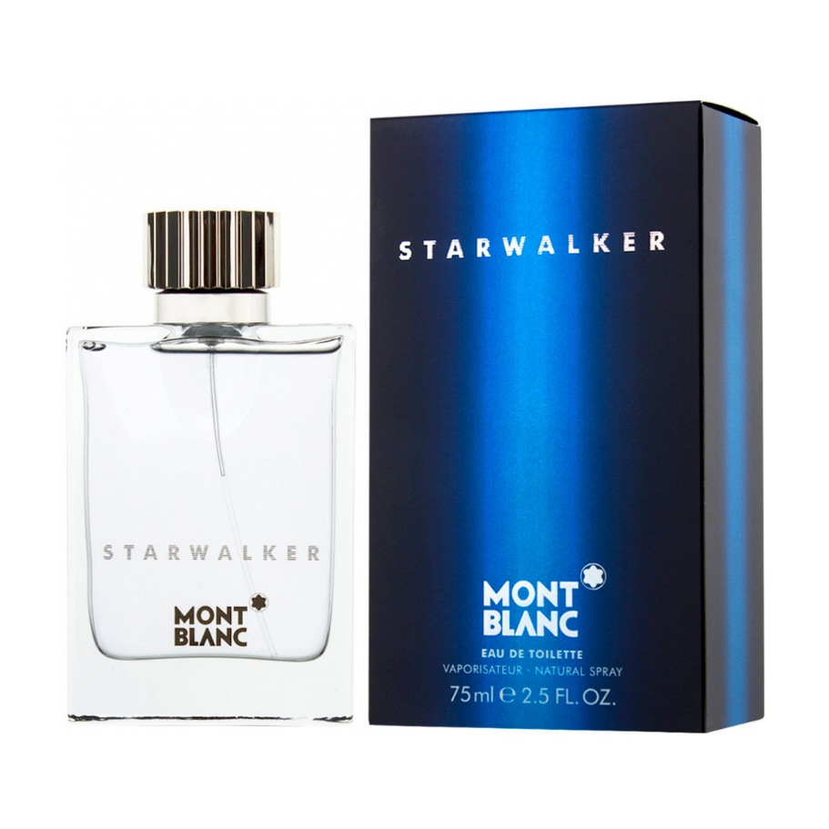**Starwalker** by **Montblanc** is a Woody Spicy fragrance for men. **Starwalker** was launched in 2005. The nose behind this fragrance is Michel Almairac. Top notes are Bamboo, Bergamot and Mandarin Orange; middle notes are Sandalwood, White Musk and Cedar; base notes are Ginger, Fir Resin, Nutmeg and Amber